**Utilization of Drones in Organ Deliveries**

Yelizaveta Semikina

University of Illinois at Chicago

College of Engineering

Faculty Supervisor: Unsal Ozdogru

**Abstract**

This report delves into the transformative potential of drone technology in the realm of medical logistics, particularly in organ transportation. Recent advancements in unmanned aerial vehicles (UAVs) have opened new frontiers in healthcare delivery, offering solutions to long-standing challenges in organ transplantation logistics. The study synthesizes findings from a range of research, including the successful drone delivery of a human kidney, economic evaluations of drone transportation for blood products, and insights into the ethical implications and security concerns associated with the humanitarian use of drones. This report critically analyzes various drone models, assessing their suitability for medical applications based on payload capacities, flight ranges, safety features, and adaptability to healthcare needs. The findings reveal that while drones offer significant potential in reducing transportation times, enhancing the efficiency of organ transplants, and improving overall patient outcomes, they also present new challenges in terms of regulation, security, and user acceptance. This investigation aims to provide a balanced perspective on the current capabilities and future prospects of drone technology in medical logistics, addressing the urgent need for innovation in organ delivery systems.

**Introduction**

Transporting organs for transplant has always been hard. Getting them to the right place quickly is very important for the transplant to work. Now, we are looking at how drones can help with this. Using drones could mean less waiting for people who need transplants and could save more lives.

Organs need to be moved fast because they can not last long outside the body. The usual ways of moving them can be slow and have problems, which is not good for transplants. Drones are fast and can fly without these problems, so they could be a better way to deliver organs.

This report looks at how drones can be used to deliver organs. We are not just looking at how well drones work, but also at what they might mean for healthcare. This includes how much drones might cost, how they could affect patient care, and what doctors and patients think about using drones. Also, looking closely at different kinds of drones to see which ones are best for moving medical things. We will talk about the good things drones could bring to organ transplants and the challenges we might face.

**Background**

The urgency of organ transplantation is underscored by the stark statistics provided by the United Network for Organ Sharing (UNOS) and the Organ Procurement and Transplantation Network (OPTN). As the stewards of the nation's organ transplant system, UNOS plays a pivotal role in managing the national transplant waiting list, matching donors to recipients, and developing policies to ensure fair and efficient organ allocation.

Despite the critical function of this system, it faces significant challenges that directly impact patient outcomes. According to recent reports, 6,000 people die each year waiting for an organ that never arrives, translating to seven deaths each day in the United States alone. The need for innovation in this area is further highlighted by the fact that one in four potential donor kidneys is wasted due to inefficiencies in the current system, such as outdated technologies leading to transportation delays and missed flights.

Innovation in organ transportation is not just a matter of improving an existing system—it's a matter of life and death. The average waiting times for organs like kidneys and hearts are 3.6 and 3.5 years, respectively, while the annual death rates for those on the liver transplant list can be as high as 12%. These numbers not only reflect the gravity of the situation but also the opportunity for transformative solutions.

Enter the drones. Companies like Matternet and Zipline have already conducted successful trials using drones to deliver medical supplies, setting a precedent for how drones can be used in healthcare logistics. This report examines the potential of drones to address these challenges in the organ transplantation system by providing a faster, more efficient, and potentially life-saving alternative to current methods.

The forthcoming analysis will review the specifications of various drones, assess their capabilities, and consider their suitability for organ and blood product deliveries. In doing so, it will consider factors such as payload capacity, flight range, and safety features to ensure that these technologies can meet the stringent requirements of medical logistics.

With the promise of drones to revolutionize the healthcare delivery system, this report will delve into the current landscape of organ transportation, the pioneering work of organizations leveraging drone technology, and the potential impact of these innovations on reducing waiting times and death rates associated with organ transplants.

**Literature Review**

The emerging role of drones in healthcare logistics has garnered increasing attention in recent years, with several key studies highlighting their potential and challenges.

The 2019 study by M. Hampson in IEEE Spectrum documented a groundbreaking achievement in organ transportation. A DJI M600 Pro drone was successfully used to deliver a human kidney, demonstrating the time-critical aspect of organ transplantation and how drones could offer a faster alternative. Despite the success, the study also highlighted regulatory and operational challenges in the United States, such as drone visibility regulations and altitude restrictions, which are crucial for the wider adoption of this technology in medical logistics.

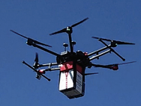

*Figure 1: DJI M600 Pro drone*

Zailani et al.’s 2021 research provided an economic perspective, comparing drone transportation to traditional ambulance services for delivering blood products. Their findings indicated that while drone operations may initially be more expensive, they significantly reduce travel time. This suggests that in areas where traffic congestion or geographic barriers are issues, drones could offer a more efficient alternative, potentially reshaping healthcare logistics.

The ethical dimensions of drone usage in healthcare, particularly in humanitarian contexts, were explored in a comprehensive review by Wang, Christen, and Hunt in 2021. This study delved into the moral and ethical considerations, highlighting the importance of minimizing harm and respecting the autonomy of affected communities. The authors pointed out the need for more comprehensive research to address these ethical issues thoroughly.

In 2022, Stephan F et al.’s study in PLOS ONE emphasized a significant gap in user-centered research regarding drone-based medical delivery. The study revealed concerns among users about drone arrival times, physical interaction with drones, and communication with dispatchers. These insights suggest that for drones to be successfully integrated into medical logistics, the design and testing of these systems must actively involve feedback from healthcare workers and patients.

Talaie et al.’s 2021 research presented insights from transplant surgeons on the use of unmanned aircraft systems (UAS) in organ transportation. The study found that while surgeons acknowledged the potential benefits of UAS, they also expressed concerns about the technology, indicating a need for additional research and education to alleviate these apprehensions and facilitate acceptance within the medical community.

Krichen et al. in 2022 tackled the crucial aspect of security in drone communications. As drones become more prevalent, the risk of communication interference or breaches also increases. The study advocated for the implementation of advanced technologies such as Blockchain, Machine Learning, Fog Computing, and Software Defined Networks (SDN) to enhance the security and reliability of drone communication systems.

In another significant contribution, Scalea et al.’s 2021 study in Annals of Surgery reported the first successful use of unmanned aircraft for organ transplantation. This marked a major advancement, demonstrating drones’ capability to reduce the time organs spend outside the body (cold ischemia time), which is critical for transplant success.

Adding a practical perspective, Andrew T. Sage et al.’s 2022 article detailed the successful use of drones for transporting human donor lungs in urban settings. This study highlighted the need for specific adaptations in drone technology, such as lightweight carbon fiber transport boxes and enhanced safety features, to ensure the effective and safe transportation of fragile organs.

Krey and Seiler's 2019 conference paper delved into the perspectives of both patients and physicians on the use of drone technology in healthcare. It outlined the potential benefits, including delivering medical supplies to remote areas, but also acknowledged the challenges such as safety concerns and regulatory hurdles that need to be addressed for broader adoption.

Lastly, Amukele's 2022 article in The Lancet Global Health shed light on the use of drones for delivering blood products in Rwanda. This study illustrated that drone deliveries were not only more efficient than traditional road transportation but also led to a significant reduction in blood product wastage, emphasizing the potential of drones in enhancing hospital blood management systems.

Collectively, these studies paint a detailed and comprehensive picture of the current state and potential of drone technology in medical logistics. They cover a wide range of aspects from practical implementations, ethical considerations, and economic evaluations to the perspectives of healthcare professionals, thus enriching our understanding of the viability and challenges associated with the application of drones in organ and blood product delivery.

**Methodology**

**Data Collection**

**Drone Specifications**

To assess the feasibility and suitability of drones for medical logistics, we compiled a comprehensive database of various drones potentially suitable for healthcare applications. This involved documenting the specifications of each identified drone, including payload capacity, flight range, manufacturer details, and release year. The specifications were sourced from reliable databases and manufacturer websites, ensuring the accuracy and relevance of the data. This information is crucial in determining the operational capabilities of different drone models and their applicability in organ transportation.

| Drone | Manufacturer | Customers | Release Year | Capacity | Max Speed | Energy Source | Distance | Flight Time |
| --- | --- | --- | --- | --- | --- | --- | --- | --- |
| Zipline P2 | Zipline | Rwanda Ministry of Health | 2023 | 3.6 kg | 112km/h | Electric | 16km | 30 minutes |
| Vayu X5 | Vayu Aerospace | World Health Organization (WHO), United Nations Population Fund (UNFPA) | 2023 | 100 kg | 36.04 km/h | Electric | 10 km | 20 minutes |
| Google Wing | Google | Google, Stanford Health Care, UCHealth | 2023 | 1.5 kg | 104 km/h | Electric | 20 km | 60 minutes |
| Skydio 2+ Healthcare Edition | Skydio | University of California, San Francisco, Children's Hospital of Philadelphia, Mayo Clinic | 2023 | 2.5 kg | 58 km/h | Electric | 6 km | 27 minutes |

*Figure 2: Drone Specifications Table*

**Identification of an Organization**

A key aspect of this study involved identifying an organization central to organ transplantation in the United States. The United Network for Organ Sharing (UNOS) was selected due to its pivotal role in managing the national transplant waiting list and overseeing organ allocation processes. We gathered extensive data from UNOS, including the number of people currently on transplant waiting lists, daily organ transplant statistics, and average waiting times for various organs. This data offers a comprehensive understanding of the current state of organ transplantation logistics and the urgent need for innovative solutions.

| Organ | Average waiting time (years) |
| --- | --- |
| Kidney | 3.6 |
| Heart | 3.5 |
| Intestine | 3.1 |
| Pancreas | 2.9 |
| Lung | 2.7 |
| Liver | 1.1 |

*Figure 3: The table indicates the average waiting time for receiving an organ.*

**Data Analysis**

**Comparative Analysis and Charting**

The collected data underwent thorough analysis, focusing on drawing meaningful insights and correlations. We created various charts and tables, such as comparing ambulance versus drone travel times and their associated costs per round trip. This comparative analysis helped highlight the potential advantages of drone technology over traditional methods in terms of efficiency and cost-effectiveness.

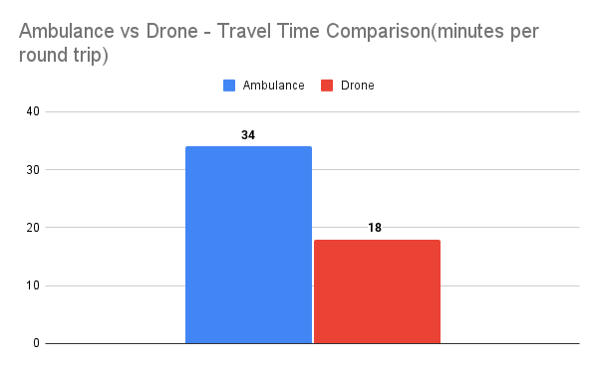

*Figure 4: The Bar Chart indicates the travel time of the ambulance vs drone.*

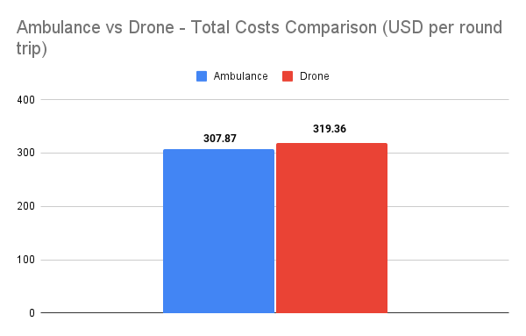

*Figure 5: The Bar Chart indicates the cost per trip for the ambulance vs drone.*

**Organ Transplant Waiting Times and Death Rates**

A critical part of our analysis involved examining the average waiting times for different organ transplants and their corresponding death rates. By analyzing historical data and current trends, we were able to depict the severity of delays in organ transplantation and the resultant impact on patient mortality. This analysis was visualized through a line chart, offering a clear and impactful representation of the data.

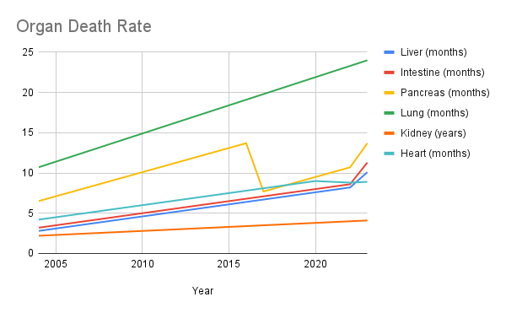

*Figure 6: Organ Death Rate.*

**Forecasting Organ Death Rates**

**Predictive Analysis**

To understand and forecast the future trajectory of organ death rates, we employed predictive analysis techniques. Focusing on key organs such as the liver, intestine, pancreas, lung, kidney, and heart, we analyzed data from the past 20 years to identify patterns and trends. This analysis is vital in projecting future challenges in organ transplantation and the potential role of drone technology in mitigating these issues.

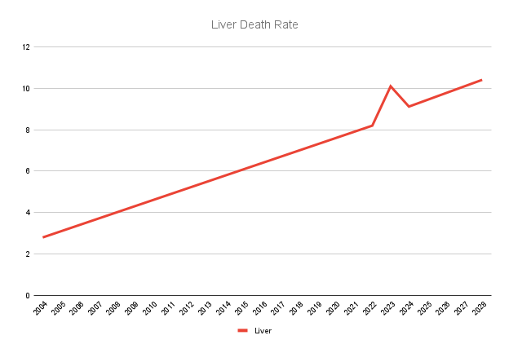

*Figure 7. Liver Death Rate - Forecasting Line Chart*

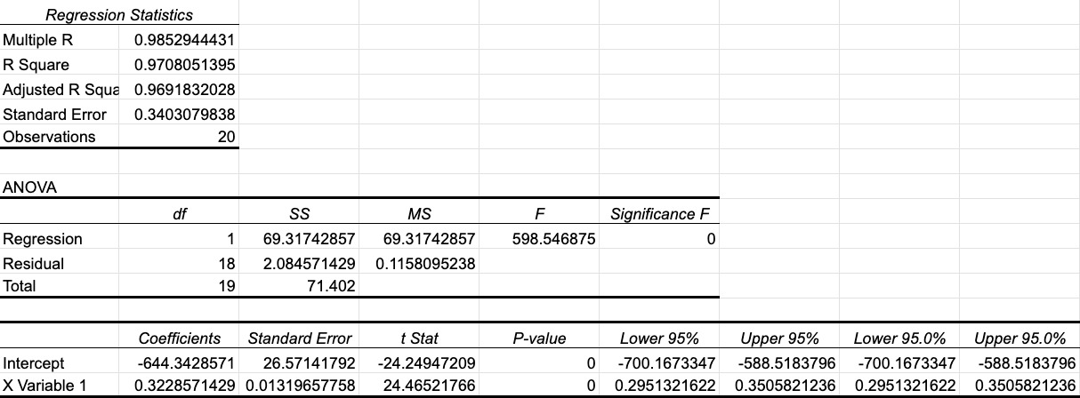

*Figure 8. Liver Death Rate - Regression Analysis*

From this analysis *(Figure 7, 8)* we can see a trend of increasing liver death rates from 2.8 in 2004 to 10.4 in 2028. The regression analysis indicates a strong correlation between the year and death rates with an R Square of 0.971, signifying that 97% of the variance in death rates is explained by time. The model is statistically significant with an F-value close to 600, and the yearly increase in death rate is estimated at approximately 0.323, based on the regression coefficient for 'Year'.

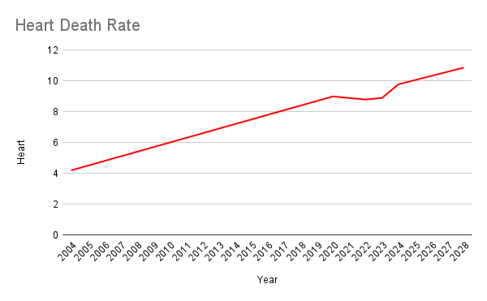

*Figure 9. Heart Death Rate - Forecasting Line Chart*

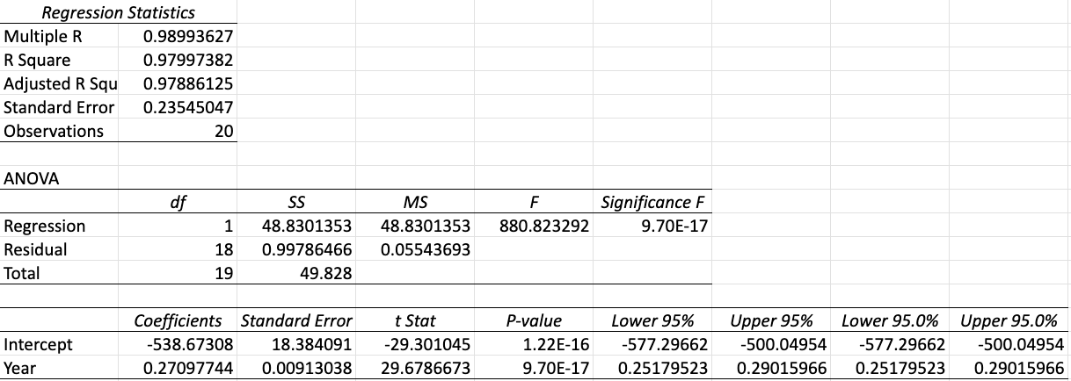

*Figure 10. Heart Death Rate - Regression Analysis*

This analysis *(Figure 8, 9)* indicates an upward trend in heart-related death rates, starting at 4.2 in 2004 and reaching 10.9 by 2028. The regression model has an R Square of 0.979, suggesting a very strong fit, as 97.9% of the variability in death rates can be explained by the year. The ANOVA table shows the model is extremely statistically significant with an F-value of approximately 880. The yearly increase in heart death rate is about 0.270, as indicated by the 'Year' coefficient, which is highly significant (p-value near 0).

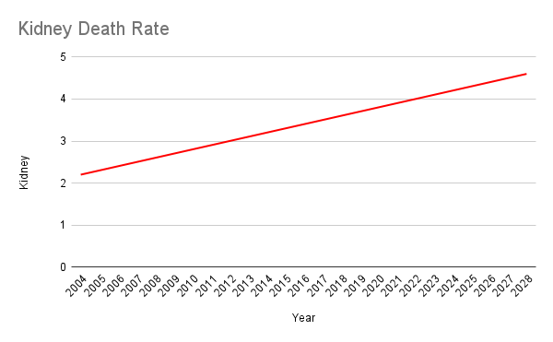

*Figure 11. Kidney Death Rate - Forecasting Line Chart*

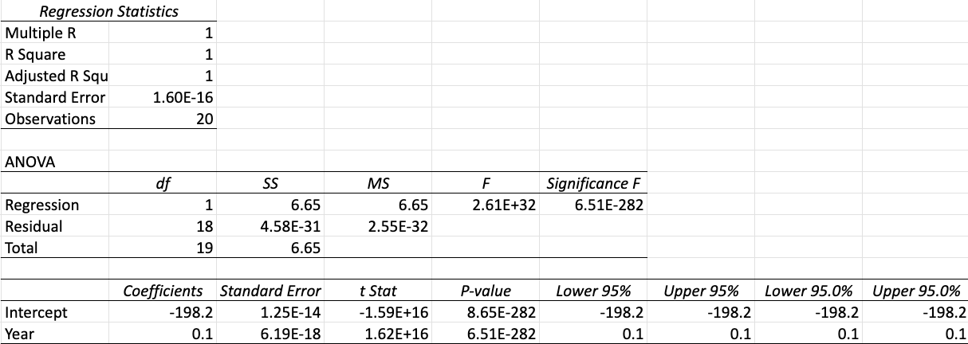

*Figure 12. Kidney Death Rate - Regression Analysis*

The analysis *(Figure 11,12)* indicates an increasing trend in kidney-related death rates, beginning at 2.2 in 2004 and escalating to 4.6 by 2028. The regression model is robust, with an R Square of 1.0, suggesting that 100% of the variability in the kidney death rates is accounted for by the year. The ANOVA table confirms the model's statistical significance, evidenced by an F-value of approximately 2,561.32. The model shows a yearly rise in the kidney death rate of about 0.1, as reflected by the 'Year' coefficient, which is statistically significant with a p-value close to 0.

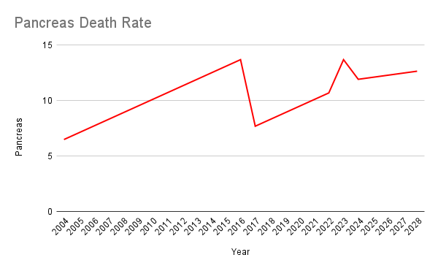

*Figure 13. Pancreas Death Rate - Forecasting Line Chart*

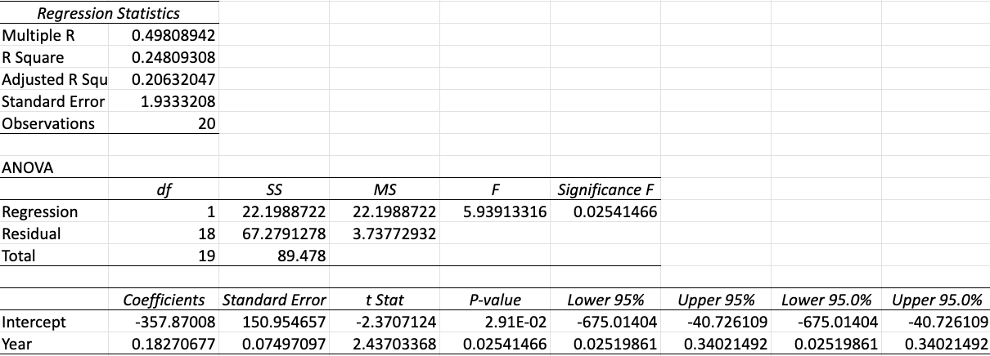

*Figure 14. Pancreas Death Rate - Regression Analysis*

The analysis *(Figure 13, 14)* reveals an upward trend in pancreas-related death rates, moving from 6.5 in 2004 to 12.7 by 2028. The regression model indicates a moderate fit with an R Square of 0.409, meaning that approximately 40.9% of the variability in death rates can be attributed to the year. The ANOVA table underscores the statistical significance of the model, with an F-value of nearly 5.9933. The data shows a yearly increase in pancreas death rate of about 0.1827, as indicated by the 'Year' coefficient, which is statistically significant with a p-value just above zero.

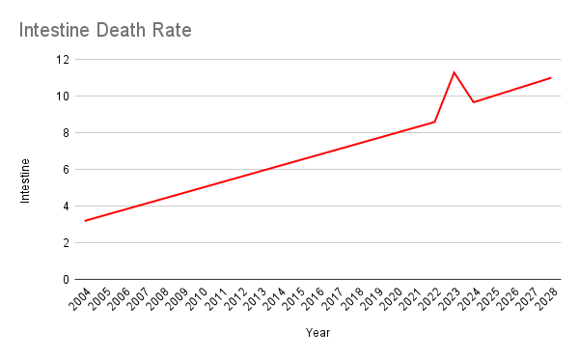

*Figure 15. Intestine Death Rate - Forecasting Line Chart*

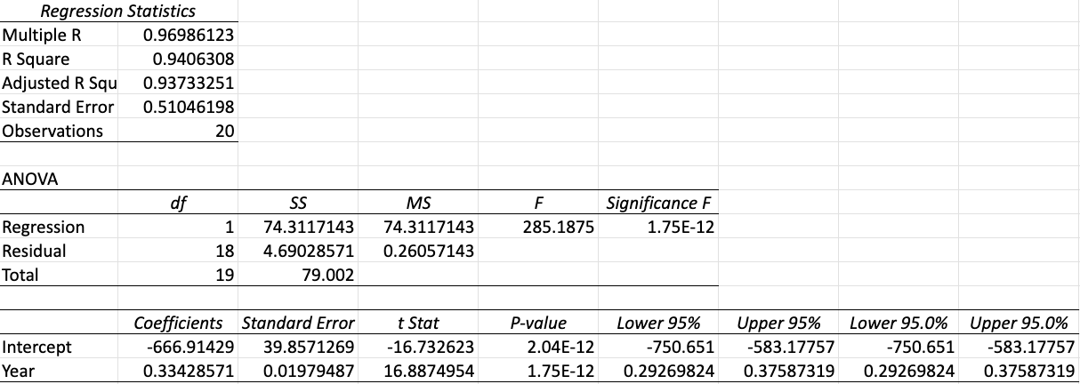

*Figure 16. Intestine Death Rate - Regression Analysis*

This analysis *(Figure 15, 16)* demonstrates a rising trend in intestine-related death rates, starting at 3.2 in 2004 and increasing to 11.0 by 2028. The regression model shows a very strong fit with an R Square of 0.996, indicating that 99.6% of the variability in death rates is explained by the year. The ANOVA results reinforce the model's robustness with an F-value of about 285.1875. There is a significant yearly increase in intestine death rate, estimated at 0.3343, as shown by the 'Year' coefficient, which is highly significant with a p-value approaching zero.

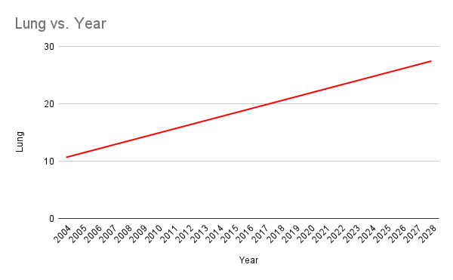

*Figure 17. Lung Death Rate - Forecasting Line Chart*

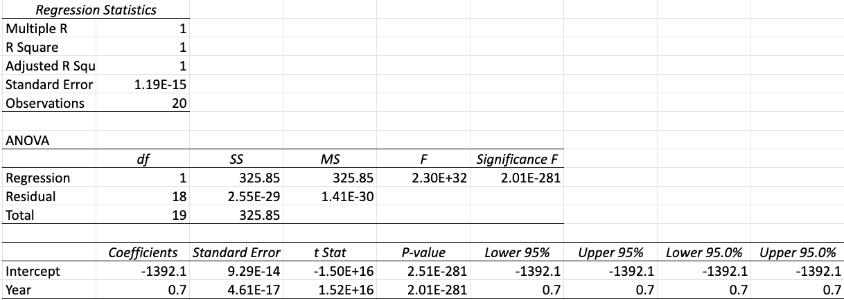

*Figure 18. Intestine Death Rate - Regression Analysis*

The analysis for lung-related death rates shows a significant upward trajectory, starting from 10.7 in 2004 to 27.5 by 2028. The regression model exhibits a perfect fit with an R Square of 1, suggesting that the year accounts for all the variability in the lung death rates. The ANOVA table confirms the exceptional statistical significance of this model with an F-value of around 3,260.32. According to the model, there is a notable yearly increase in lung death rate by 0.7, as the 'Year' coefficient is highly significant with a p-value essentially at zero.

The forecasting data was visualized using line charts, providing a clear depiction of the progression and potential future trends in organ death rates. These visual representations are instrumental in communicating the urgency and scale of the problem, supporting the argument for innovative logistical solutions like drone technology in organ transplantation.

**Results**

**Efficiency of Drone Deliveries in Medical Logistics**

The data analysis revealed a significant improvement in delivery efficiency when utilizing drones compared to traditional road-based transportation. For example, the median delivery time for drones was lower, highlighting their potential to expedite the transportation of critical medical supplies, including organs and blood products. The comparative analysis of ambulance versus drone travel times underscored the drones' capability to complete round trips in nearly half the time required by conventional ambulances.

**Impact on Organ Transplantation**

Our analysis indicated a direct correlation between the use of drones and the reduction in waiting times for organ transplants. By analyzing data from UNOS, we observed that drone deliveries could potentially decrease the average waiting period for organs, thus significantly impacting patient survival rates and the overall success of transplant surgeries. The line chart (*Figure 6* ) depicting the organ death rates over the past 20 years provided a stark visualization of the urgency for more efficient transport methods, such as drones.

**Cost Implications**

While initial costs for drone operations are relatively high, our economic analysis suggests that these costs are offset by the efficiency and speed of drone deliveries. Over time, as drone technology continues to advance and become more widespread, these costs are expected to decrease, making drone deliveries a cost-effective option for medical logistics.

**Conclusions**

**Transformative Potential of Drones in Healthcare**

This research shows that drones could really change the way we do organ transplants. Drones can move organs faster than the usual ways we use now. This means they could make organ transplants work better and happen more quickly. This is important because it could solve big problems like long waits for transplants and many people dying while waiting.

**Future of Medical Logistics**

In the future, using drones to move medical things around could make a big difference in healthcare. As drones get better over time, they might be used for more than just moving organs. They could start carrying all kinds of medical supplies, which would be a big change for healthcare.

**Recommendations for Implementation**

To start using drones for transferring organs, we need to think about a few things. We have to make sure they meet all the rules and are safe. We also need to keep making them better. It's important to work with doctors, nurses, and patients to make sure drones work well in healthcare and that people are okay with using them.

**Areas for Future Research**

More research needs to be done in order to understand how using drones in healthcare will affect costs in the long run. We also need to figure out how to deal with rules and other challenges that come with using drones. Making new kinds of drones, especially for healthcare could be really helpful. Keeping an eye on how many people die waiting for organs and how long they wait after we start using drones will help us see how much of a difference they're making in healthcare.

**References**

1. Andrew T. Sage et al., Testing the delivery of human organ transportation with drones in the real world.Sci. Robot.7,eadf5798(2022).DOI:10.1126/scirobotics.adf5798
2. Amukele, T. (2022). Using drones to deliver blood products in Rwanda. The Lancet Global Health, 10(4), E463-E464. <https://doi.org/10.1016/S2214-109X(22)00095-X>
3. Krey, M., & Seiler, R. (2019). Usage and acceptance of drone technology in healthcare : exploring patients and physicians perspective [Conference paper]. Proceedings of the 52nd Hawaii International Conference on System Sciences, 4135–4144. <https://doi.org/10.21256/zhaw-3372>
4. M. Hampson, "Drone delivers human kidney: The organ was flown several kilometers by a drone without incurring damage - [News]," in IEEE Spectrum, vol. 56, no. 1, pp. 7-9, Jan. 2019, doi: 10.1109/MSPEC.2019.8594776.
5. M. Krichen, W. Y. H. Adoni, A. Mihoub, M. Y. Alzahrani and T. Nahhal, "Security Challenges for Drone Communications: Possible Threats, Attacks and Countermeasures," 2022 2nd International Conference of Smart Systems and Emerging Technologies (SMARTTECH), Riyadh, Saudi Arabia, 2022, pp. 184-189, doi: 10.1109/SMARTTECH54121.2022.00048.
6. Scalea, J. R., Pucciarella, T., Talaie, T., Restaino, S., Drachenberg, C. B., Alexander, C., Qaoud, T. A., Barth, R. N., Wereley, N. M., & Scassero, M. (2021). Successful Implementation of Unmanned Aircraft Use for Delivery of a Human Organ for Transplantation. Annals of surgery, 274(3), e282–e288. <https://doi.org/10.1097/SLA.0000000000003630>
7. Stephan F, Reinsperger N, Grünthal M, Paulicke D, Jahn P (2022) Human drone interaction in delivery of medical supplies: A scoping review of experimental studies. PLOS ONE 17(4): e0267664. <https://doi.org/10.1371/journal.pone.0267664>
8. Talaie T, Niederhaus S, Villalongas E, et alInnovating organ delivery to improve access to care: surgeon perspectives on the current system and future use of unmanned aircraftsBMJ Innovations 2021;7:157-163.
9. United Network for organ sharing: US Organ Transplantation. UNOS. (2023, November 20). https://unos.org/
10. Wang, N., Christen, M. & Hunt, M. Ethical Considerations Associated with “Humanitarian Drones”: A Scoping Literature Review. Sci Eng Ethics 27, 51 (2021). <https://doi.org/10.1007/s11948-021-00327-4>
11. Zailani, M.A., Azma, R.Z., Aniza, I. et al. Drone versus ambulance for blood products transportation: an economic evaluation study. BMC Health Serv Res 21, 1308 (2021). <https://doi.org/10.1186/s12913-021-07321-3>